5040m. d-Tetramethrin

GC and LC method 5040m

CIPAC Small Scale Collaborative Trial

Jiangsu Yangnong Chemical Co., Ltd.
YANGZHOU

China

June 2016

d-Tetramethrin
5040/TC/M

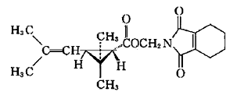

ISO common name: Not available

Other names: d-tetramethrin

Chemical name: (1,3,4,5,6,7-Hexahydro-1,3-dioxo-2H-isoindol-2-yl)methyl (1R-trans)-2,2-dimethyl-3-(2-methylprop-1-enyl)cyclopropanecarboxylate

CAS-Number: 1166-46-7

RMM: 331.42

Empirical formula: C₁₉H₂₅NO₄

m.p. 48 °C

V.p. 9.5x 10⁻⁴ Pa at 30°C

Solubility In water at 20 °C: insoluble
In toluene: >200 g/l at 20°C
In acetone: >200 g/l at 20°C

Stability Stable at ambient temperature

Description Yellow to brown liquid

Note: d-tetramethrin is a mixture of the isomers (1R-trans, R), (1R-trans, S), (1R-cis, R) and (1R-cis, S) of tetramethrin in an approximate ratio of 4:4:1:1. In practice the trans isomer range is 75-85 %and the cis isomer range is 15-25 %.

d-Tetramethrin technical
5040m/TC/M/-

1 Sampling. Take at least 100 g.

2 Identity test

2.1 Infrared. Prepare a film between KBr plates and scan from 4000 to 400 cm⁻¹. The spectrum produced from the sample should not differ significantly from that of the standard.
2.2 HPLC. Use the normal phase HPLC method below. The relative retention time of the respective peak in the sample solution should not deviate by more than 1.5% from that of the calibration solution.

n-heptane HPLC grade
Ethanol HPLC grade
Diethylamine AR grade
Mobile phase. Add 1 ml diethylamine and 70 ml ethanol to 930 ml n-heptane and mix. Mixing of the mobile phase may also be accomplished using a binary solvent HPLC pump. Filter and degas the mobile phase prior to use.
APPARATUS
High performance liquid chromatograph equipped with a normal-flow pump, normal-temperature chiral column compartment, a sample injector capable of injecting 3 μl aliquots, a UV detector (230 nm) and digital integrator or other data-handling capability. A chilled autosampler should be used, if available (but is not required).
HPLC column CHIRALCEL® AY-H, 250 × 4.6 mm (i.d.), 5 μm particle size;
Ultrasonic bath

(a) Operating conditions (typical)
Column 250 × 4.6 mm (i.d.), packed with CHIRALCEL® AY-H, 5 μm particle size
Mobile phase n-heptane-ethanol-diethylamine, 930+70+1 (v/v)
Column temperature 35 ℃
Flow rate 1.0 ml/min
Injection volume 3 μl
Detector wavelength 230 nm
Run time approximately 20 min
Retention time 1S-cis isomer: about 7.7 min
1R-cis isomer: about 9.0 min
1R-trans isomer: about 10.0 min
1S-trans isomer: about 11.4 min
(b) Sample preparation. Melt the sample and homogenize thoroughly by stirring prior to sampling. Prepare a solution of approximately 250 mg/l of the sample in mobile phase. Inject 3 μl of this solution.
(c) Equilibration of the system. Inject 3 μl portions of the sample solution and repeat the injections until retention times and peak areas vary by less than 1.0% of the mean for 3 successive injections.
(d) Determination. Inject 3 μl of the sample solution and determine the respective peak areas.
(e) Calculation. Calculate the trans isomer and 1R isomer fraction percentage of the four isomers.
Trans isomer fraction percentage$=\frac{H_{c}+H_{d}}{H_{a}+H_{b}+H_{c}+H_{d}}×\text{100}\text{\%}$
1R isomer fraction percentage$=\frac{H_{b}+H_{c}}{H_{a}+H_{b}+H_{c}+H_{d}}×\text{100}\text{\%}$
Where:
H_{a} = area of the 1S-cis isomer
H_{b} = area of the 1R-cis isomer
H_{c} = area of the 1R-trans isomer
H_{d} = area of the 1S-trans isomer

3 d-Tetramethrin

OUTLINE OF METHOD. d-Tetramethrin is determined by gas chromatography with internal standardization and flame ionization detection.

REAGENTS

Dichloromethane
Tetramethrin working standard with known content
Di-(2-ethylhexyl)-O-phthalate (DOP) internal standard. Must not show peaks with the same retention times as Tetramethrin.
Internal standard solution. Dissolve DOP (1.0 g) in dichloromethane (100 ml). Ensure that a sufficient quantity of this solution is prepared for all samples and calibration standards to be analysed.
Calibration solution. Prepare calibration solutions in duplicate. Weigh (to the nearest 0.1 mg) 90 to 110 mg (s mg) of tetramethrin working standard into a volumetric flask (20 ml). Add by pipette internal standard solution (5.0 ml) and dissolve completely. Make up to volume with dichloromethane and mix well (solutions C_{A} and C_{B}).

APPARATUS

Gas chromatograph capable of operating in the range 240 ℃ equipped with a flame ionisaton detector, a split injector and an autosampler
Column quartz, 30 m × 0.25 mm (i.d.), coated with 50% (trifluoropropyl)-methylpolysiloxane (e.g DB-210), film thickness 0.25 μm
Electronic integrator or data system

PROCEDURE

(a) Chromatographic conditions (typical)
Column quartz, 30 m × 0.25 mm (i.d), coated with 50% (trifluoropropyl) -methylpolysiloxane (e.g DB-210), film thickness 0.25 μm
Injection System
Injector Split injection
Split ratio 30:1
Detector Flame ionization
Temperatures
Injector 250 ℃
Detector 280 ℃
Oven 240 ℃
Injection volume 1 μl
Gas flow rates
Helium (carrier) 1.6 ml/min
Hydrogen about 40 ml/min
Air about 400 ml/min
Helium (make up) about 30 ml/min
Run time about 10 min
Retention times d- tetramethrin: about 7.4 min + 8.0 min

DIOP about 5.7 min

(b) Linearity check. Check the linearity of the detector response by injecting 1 μl of solutions with tetramethrin concentrations 0.5, 1 and 2 times that of the calibration solution before conducting the analysis.

(c) Equilibration of the system. Prepare two calibration solutions. Injection 1 μl portions of the first calibration solution C_{A} and repeat the injections until the peak area ratio of tetramethrin to the internal standard obtained from two consecutive injections of C_{A} deviate by less than 1.0%. Then the ratio for the second calibration solution C_{B} should not deviate by more than 1.0% from that for C_{A}. Otherwise prepare new calibration solutions.

(d) Sample preparation. Prepare sample solutions in duplicate for each sample. Weigh (to the nearest 0.1 mg) 90 to 110 mg d- tetramethrin (w mg) of sample into a volumetric flask (20 ml). Add by pipette internal standard solution (5.0 ml) and dissolve completely. Make up to volume with dichloromethane and mix well (solutions S_{A} and S_{B}).

(e) Determination. Injection in duplicate 1 μl portions of each sample solution bracketing them by injections of the calibration solutions as follows: calibration solution C_{A}, sample solution S_{A}, sample solution S_{A}, calibration solution C_{B}, sample solution S_{B}, sample solution S_{B}, calibration solution C_{A}, and so on. Measure the relevant peak areas.

(f) Calculation. Calculate the mean value of each pair of response factors bracketing the two injections of a sample and use this value for calculating the d- tetramethrin contents of the bracketed sample injections.

$$f_{i}=\frac{I_{r}×s×P}{H_{s}}$$
Content of d- tetramethrin $=\frac{f×H_{w}}{I_{q}×w}g/{\text{kg}}$
Where:
f_{i} = individual response factor
f = mean response factor
H_{s} = peak area of d- tetramethrin in the calibration solution
H_{w} = peak area of d- tetramethrin in the sample solution
I_{r} = peak area of the DOP in the calibration solution
I_{q} = peak area of the DOP in the sample solution
s = mass of tetramethrin in the calibration solution (mg)
w = mass of sample taken (mg)
P = purity of tetramethrin standard (g/kg)
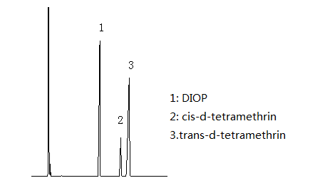
Figure 1 Gas Chromatogram of d- tetramethrin technical
Figure 2 Infrared spectrum of d- tetramethrin

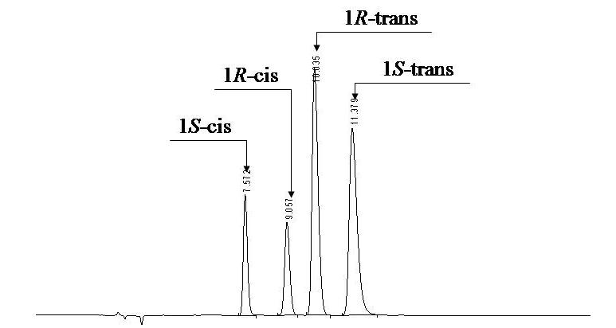
Figure 3 HPLC Chromatogram of tetramethrin technical

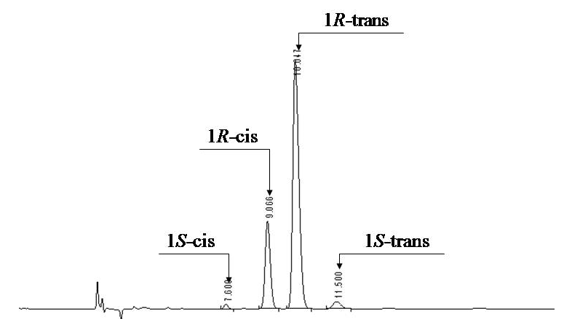
Figure 4 HPLC Chromatogram of d-tetramethrin technical

